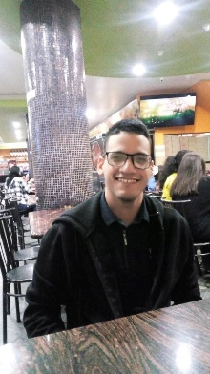

**EXPERIENCE** **| TAILWINDCSS** | **REACT.JS/VUE.JS** **| NODE.JS**

**university graduate | UNELLEZ**

**Francisco Gonzalez**

I created an attractive and functional website for a restaurant, enhancing the customer experience and increasing online reservations. I used Bootstrap to create a responsive design and JavaScript to add interactivity, allowing customers to easily and intuitively explore the menu, make reservations, and obtain information about the restaurant.

FEBRUARY. 2024 –JANUARY. 2024

I established an attractive and effective landing page for a camera installation company, increasing the brand's online visibility and impact. I used Bootstrap for a responsive design and JavaScript to add interactivity, creating an intuitive and effective user experience that captures visitors' attention and converts them into potential clients.

**Restaurant Chinese Gril**| **independent project**

I created an attractive and functional website for a restaurant, enhancing the customer experience and increasing online reservations. I used Bootstrap to create a responsive design and JavaScript to add interactivity, allowing customers to easily and intuitively explore the menu, make reservations, and obtain information about the restaurant.

I developed and designed an attractive and effective landing page for a real estate company, with the goal of converting visitors into clients. The page features a clear and modern structure, with sections including header, hero, features, properties, testimonials, call-to-action, and footer. I used Bootstrap and JavaScript to build the page, and ensured that it was responsive and visually appealing on different devices and screen sizes.

**Inmobiliary** **| independent project**

AUGUST. 2023 –AUGUST. 2023

JANUARY. 2023 –JANUARY. 2023

**jrsecurity22cam**| **independent project**

MAY. 2023 – MAY. 2023

**Chicksgold** **| independent project**

**Front-End Developer**

* GIT
* DISCORD
* JIRA

**COMPETENCIAS**

Frandeveloper21@gmail.com

**Secondary School | Alto Barinas Norte**

**FORMATION**

Barinas, Venezuela

**CONTACTO**

0424-5178409